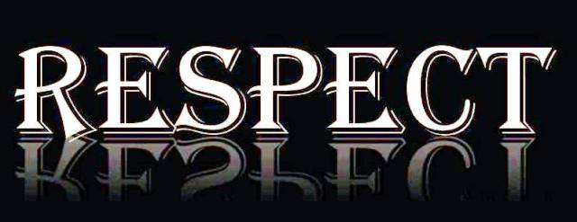
AIMS
To promote the real sense of respect
- To discuss how being respectful makes people feel.
- To understand the poblems caused by disrespectfullness
- To take care of the environment
TOPİCS
- Making boards for our works
- Preparing performances for our national march, the memory of the warriors, our national sovereignty and children’s day,mother’s day
- Making traditional puppets of Hacivat and Karagöz
- Having competitions of poems,caricatures,stories,sayings
- Composing a song for environment

ACTIVITES
- The Comenius Boards
- Hacivat and Karagöz Puppet show
- The Performances for special days
- Three R’s song
- The contests
- Drawings

